**DEEP2NEURON TECH ACADEMY-INTERNSHIP 2023**

**DAY 5 -23.06.2023**

On the fifth day, we discussed the earlier day doubts and clarified. This session lasts for a small amount of time as we were given with a huge task. The task was to run 100 epochs for the ten CNN architectures and find its confusion matrix, accuracy, precision, f1 score and recall. For this, a dataset with 10 classes (multi) was given. I uploaded the folder in my drive. After that, I started with a VGG architecture and worked on it. I faced many difficulties and got errors while running the code in Jupyter notebook. I couldn’t run the code for running epochs and worked for a huge time to sort it. Then the epochs started running.

**OUTPUT:**

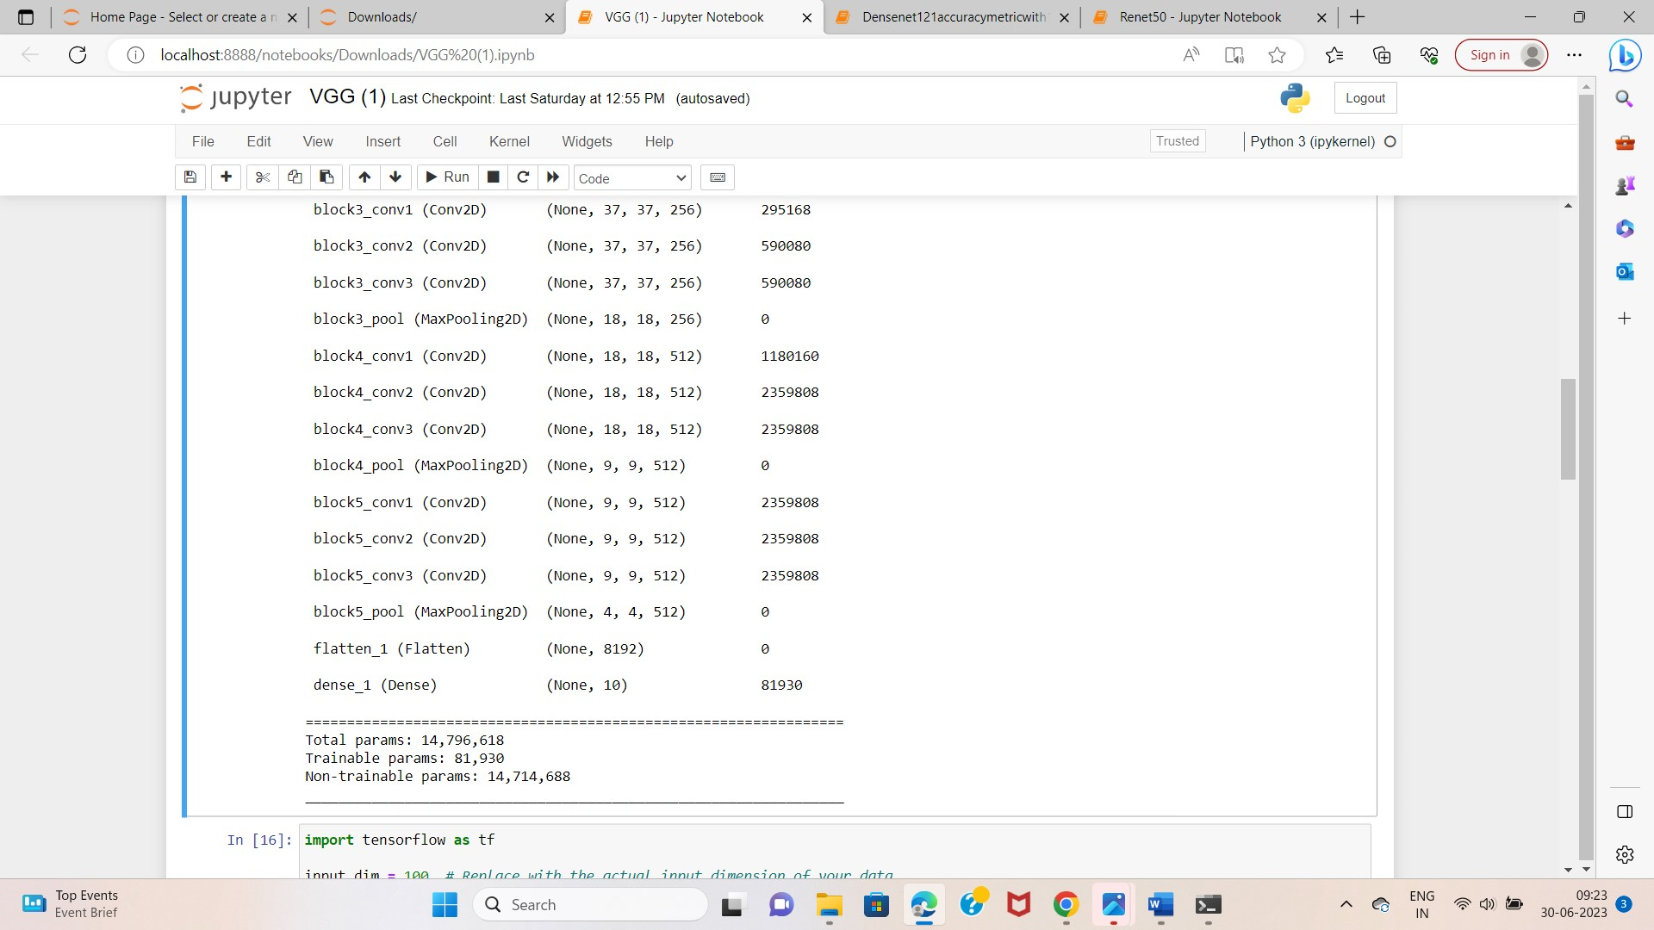

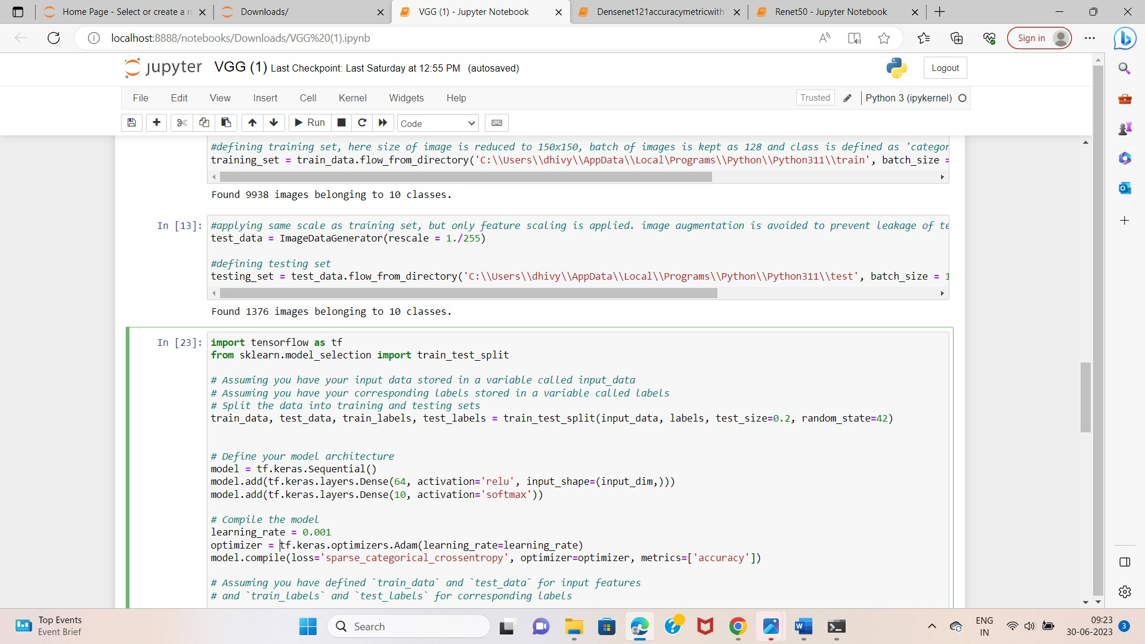

This is the progress of my project on this day. The epochs started running upto 10.